Predictive Alternating Runs and Random Task-Switching Sequences Produce Dissociative Switch Costs in the Consonant-Vowel/Odd-Even Task

Nicholas P. Maxwell, Mark J. Huﬀ, & Jacob M. Namias

The University of Southern Mississippi

Author Note

Correspondence concerning this article should be addressed to Mark J. Huff, 118 College Dr, Hattiesburg, MS, 39406. E-mail: [mark.huff@usm.edu](mailto:nicholas.maxwell@usm.edu). Code/files for all analyses have been made available at <https://osf.io/hzwc4/>. NPM is now at Midwestern State University.

Abstract

Task-switching studies are commonly used to investigate working memory and attentional control. We investigated the effects of task-switch presentation sequence on these processes. Participants completed four blocks of the Consonant-Vowel/Odd-Even (CVOE) task: Two single task pure blocks, a predictable switch block in which task switching occurred every two trials, and a random switch block in which switching was unpredictable. In addition to mean error rates and response latencies (RTs), we assessed presentation sequence effects on local switch costs (i.e., switch vs. nonswitch trials) and global costs (i.e., nonswitch vs. pure trials) for both error rates and RTs along with their underlying distributions. Overall, we show that while predictive and random switching produce similar patterns for mean error rates and RTs, a dissociation was detected in RT switch costs. When switching was random, local costs were inflated. In contrast, predictive switching increased global costs. Increased local costs for random versus predictive switching reflect an increase in task-reconfiguration processes as participants struggle to reconfigure to an unknown task type on the subsequent trial. Separately, increased global costs for predictive switching reflect declines in task-set maintenance processes, as participants must maintain both task types in working memory while simultaneously monitoring their progress through the trial sequencing.

Word Count: 203

*Keywords:* Task-Switching; CVOE; Attentional Control; Working Memory; Vincentile Plots; Ex-Gaussian Distribution

Predictive Alternating Runs and Random Task-Switching Sequences Produce Dissociative Switch Costs in the Consonant-Vowel/Odd-Even Task

The ability to attend to relevant information within one’s environment is a key aspect of goal-directed behavior. Attention plays a critical role in this process, as it is necessary to keep internal goals active in working memory long enough to affect our actions (Norman & Shallice, 1986). Thus, individuals who possess high attentional control capacities are more likely to ignore salient but unrelated information that would otherwise produce distractions. To investigate this process, researchers commonly use paradigms which present participants with task-related information, which is contrasted with information that is highly salient yet unrelated to task goals (see Rogers & Monsell, 1995; De Jong, 2000, for reviews). These studies have consistently shown that when participants are required to actively suppress task-unrelated information, both response times (RTs) and error rates are increased (e.g., Jersild, 1927; Stroop, 1935). Thus, situations which tax working memory and attentional control produce general declines in task performance.

Interest in the relationship between attentional control and task-performance is not new. In an early example, Stroop (1935) showed that both RTs and error rates increased when color-words were presented using ink that was incongruent with the word’s meaning versus a congruent ink (i.e., “blue” printed in red ink vs. blue ink). More recently, researchers have found that Stroop performance can be influenced by participants’ expectancies of upcoming trial types, including trial sequencing (e.g., congruency sequence effects; Aschenbrenner & Balota, 2019, Egner, 2007) or when items are consistently presented using an incongruent format (e.g., the word “blue” is mostly presented in yellow ink; Bugg, 2012; Jacoby, Lindsey, & Hessels, 2003). Thus, participants are slower and less accurate to respond whenever they must suppress task irrelevant information, or are affected by previous trial responses and patterns

The Stroop task has received significant attention in the literature and has been described as “the gold standard” of attentional control (see MacLeod, 1992). This is because to successfully complete the task, individuals must activate and maintain the appropriate task goal in working memory (e.g., naming the ink color) while simultaneously suppressing highly salient but task-irrelevant information (e.g., automatically reading the color name). As a result, researchers commonly use this task to investigate questions related to working memory and attentional control. For example, Kane and Engle (2003) showed a relationship between working memory span and Stroop performance. Specifically, low working memory span individuals routinely committed more errors relative to high-span individuals, particularly on incongruent trials in which ink colors and word names did not match. Similarly, Spieler, Balota, & Faust (1996) showed that age related declines in working memory and attentional control lead to decreased Stroop performance. Compared to younger adults, healthy older adults showed slower RTs (but not an increase in error rates), while older adults with Alzheimer’s Disease (AD), showed large costs to both RTs and error rates, even after being age-matched to healthy older adults. Thus, it is evident that working memory is critical for keeping internal goals active, as individuals with low working memory span or impairments each show greater difficulty maintaining desired task goals while suppressing task-irrelevant distractors.

In addition to the Stroop task, there has been an increased focus on using task-switching to investigate questions related to attentional control and working memory. In a standard task-switching experiment, participants must alternate between completing a set of contrasting tasks (e.g., Jersild, 1927; Rogers & Monsell, 1995, see De Jong, 2000; Kiesel et al., 2010 for reviews). Often, these studies present participants with at least two types of experimental conditions. First, participants complete *pure blocks* which focus exclusively on one task-set (i.e., making a stimulus decision based on a single rule). Participants then complete *switch blocks* in which they quickly alternate between two competing tasks (i.e., using a rule on one subset of stimuli, but then switching to a different rule when cued). Like the Stroop task, switch blocks require participants to keep a relevant task-set active in working memory (i.e., the current task instructions) while suppressing irrelevant but salient information from the inactive task-set. Thus, switch blocks provide a situation in which both attentional control and working memory systems are taxed. To assess the impact of stressing these systems, response times (RTs) and error rates are compared between the two block types. Overall, studies investigating task-switching have consistently found that both errors and RTs increase for switch trials versus non-switch trials, and, like the Stroop task, these costs are sensitive to breakdowns in attentional control and working memory (e.g., Huff, Balota, Minear, Aschenbrenner, & Duchek, 2015)

A distinct advantage of pure block/switch block designs is that they allow for measurement of both local and global switch costs in the same study (e.g., Huff et al. 2015; Hutchison, Balota, & Duchek, 2010; Mayr, 2001; Minear & Shah, 2008; etc.). In doing so, researchers can separately assess both the effects of actively maintaining two task-sets in working memory on task performance (e.g., switch vs. pure blocks) and the effects of alternating between task-sets within a single switch block. Participants first complete a set of pure blocks (one corresponding to each task-set individually), which are immediately followed by one or more switch blocks containing a series of interleaved switch and non-switch trials (e.g., switch, non-switch, switch, non-switch, etc.). First, the *global switch cost* refers to the response difference between non-switch trials in the switch block and pure block trials and represents the cost of maintaining multiple task-sets in a switch block compared to a single task-set within the pure block (Minear & Shah, 2008; Wylie & Allport, 2000). Thus, global switch costs likely reflect decreased performance due to the additional burden placed on working memory from having multiple-task sets activated in switch blocks relative to pure blocks in which only one task-set is active (Kiesel et al., 2010; Logan, 2007). Alternatively, the *local switch cost* refers to the difference between switch and non-switch trials presented within the same switch block. Local costs represent task-set reconfiguration processes, which are thought to reflect retrieval of the correct task set from memory (Monsell, Yeung, & Azuma, 2000). Thus, task-set reconfiguration processes are inherent to switch, but not non-switch blocks, as they are driven by participants being forced to change task-sets within the same block (Rogers & Monsell, 1995; see Huff et al., 2015).

Several factors have been shown to influence the magnitude of switch costs, including the type of stimuli being presented. For example, switch costs have been shown to be exaggerated whenever stimuli do not clearly signal to participants which of the two tasks is to be performed (Luwel, Schillemans, Ongehan, & Vershaffel; 2009). Termed *bivalent* stimuli, these items activate both task-sets used in a switch task (i.e., presenting participants with letter-number pairs and having them switch between classifying the letter or the number). Compared to *univalent* stimuli which only correspond to a single task-set (i.e., presenting participants with letters or numbers in isolation rather than simultaneously), responses to bivalent stimuli are often slowed This is because participants must keep both task-sets active in working memory and, prior to responding, must quickly consider which task-set corresponds to the correct response on a given trial (e.g., bivalency cost; Woodward, Meier, Tipper, & Graf; 2003). Several bivalent switch tasks have been developed (e.g., Stroop task switching; Spieler et al., 1996; alphabet-arithmetic task; Koch, Prinz, & Allport, 2005; etc.). One commonly used bivalent switch-task is the Consonant-Vowel/Odd-Even task (CVOE; Minear & Shah, 2008; Huff et al., 2015), which involves the classification of letter-number pairs (e.g., A 15). Depending on the cued task-set, participants are instructed to either classify the letter in the pair as a consonant/vowel or the number as odd/even. Because this task presents participants with pure and switch blocks, the CVOE task allows for computation of local and global switch costs. Thus, this task allows researchers to investigate hypothesized working memory processes in addition to factors affecting trial-level performance.

Because bivalent stimuli are more challenging for participants, researchers often incorporate them when developing task-switching paradigms. This is because the additional difficulty is particularly taxing towards participants’ working memory and attentional control systems. As a result, these stimuli are used to investigate situations in which working memory and attentional control systems are impaired. For example, Tse, Balota, Yap, Duchek, and McCabe (2010) compared performance between young, healthy older adults, and older adults with very mild Alzheimer’s Disease (AD) using three measures of attentional control, including Stroop and CVOE tasks. Although Tse et al. were primarily interested in distributional measures of RTs as a measure of attentional control processes (rather than traditional analyses of mean RTs and errors), mild AD individuals, whose working memory and attention control systems are impaired, showed greater local switch costs for errors relative to younger adults. For RTs, AD individuals showed decreased local costs compared to healthy older adults. Tse et al. attributed the increased cost to errors and the subsequent decrease in local costs to RTs as being due to AD individuals having greater difficulty suppressing the inactive task-set when switching.

More recently, Huff et al. (2015) compared CVOE task-switching between young adults, healthy older adults, and very mild AD older adults. Overall, very mild AD older adults committed more errors and had slower RTs relative to both young adults and healthy older adults, with task performance particularly affected for switch trials compared to non-switch trials in which the task-set does not change. Importantly, Huff et al. (2015) compared changes in global and local costs of both errors and RTs as a function of age and AD status. First, global switch costs (non-switch trials versus pure trials) for errors increased as a function of both age and AD status. This pattern subsequently extended to global costs of RTs, suggesting that requirement to keep two task-sets active placed additional burdens on working memory. For local costs (switch trials versus non-switch trials), however, no group differences in errors emerged, but local costs of RTs decreased across groups, suggesting that AD individuals were not as well tuned to the task-set relative to younger adults and healthy older adults. Thus, it is evident that working memory plays a critical role in task-switching performance, as individuals with impaired working memory systems have repeatedly been shown to have decreased task-switching performance.

**Predictive vs. Random Task Switching**

In addition to the type of stimuli used (e.g., bivalent vs. univalent), task-switching paradigms can be further classified based on the sequencing in which switches occur. First, switches can occur in a predictable pattern, such as an *alternating -runs* sequence (e.g., Rogers & Monsell, 1995; Huff et al., 2015). In an alternating-runs switch task, task changes occur as a function of run length (*r*), with switches occurring in *r* trial intervals (e.g., AABBAABB for *r* = 2). Because of the predictive nature of this sequence, participants are aware of when task-switches will occur. Alternatively, switches may occur at unpredictable intervals. Unlike predictive switching, in a random-switch sequence, the instructions for the upcoming task are unknown until participants are cued to change tasks. Random task switching can be further divided based on when participants receive change cues. In task-cueing paradigms (e.g., Meiran, 1996), participants receive cues at each trial, while intermittent instruction paradigms (e.g., Gopher, Armony, & Greenshpan, 2000) randomly interrupt task sequences with instructions to change (see Monsell, Sumner, Waters, 2003 for a review of task-switch sequencing).

Previous research has investigated the effects of predictive versus random switching on RTs and error rates. For example, Monsell et al. (2003) compared performance on a four-run alternating switch task to a random task-cueing switch paradigm. Overall, random switching was more difficult for participants than predictive switching, as participants in the random group took more trials to recover from a switch compared to when switching was predictive. However, direct comparisons of local and global switch costs between random and predictive switching were not included as the authors 1) were primarily interested in the effects of response-stimulus interval and run length on the local switch cost (rather than a direct comparison of presentation pattern), and 2) did not include a pure block comparison, making global switch costs unavailable.

Minear & Shah (2008) similarly had participants complete both predictive and random switching in the CVOE task. Using a pre/post design, participants first completed the full CVOE task (pure and switch blocks with predictive and random sequencing) which was followed by a battery of transfer tasks followed by a second full CVOE task 24-48 hours following the initial task. While Minear and Shah’s primary focus was on pre/post transfer effects, the authors reported higher RTs and error rates on the CVOE when switching was random versus predictive. Additionally, while statistical comparisons between local and global switch costs as function of presentation sequence were not reported, visual inspection of their pre-test CVOE data suggests that global costs increased when switching was random, while local costs increased when switching was predictive. However, given the reliability of these comparisons were unavailable, it remains unclear how switch sequencing affects task-switching costs.

**Distributional Analyses of RTs**

Task-switching paradigms commonly use RTs as indicators of task performance, which are generally analyzed in terms of mean or median scores. However, because RT distributions are almost always positively skewed (i.e., most RTs generally occurring at the faster end of the distribution), performing an analysis of only mean RTs may overlook data that are psychologically informative regarding cognitive processes (Balota & Yap, 2011, see De Jong, 2000, for a review within the context of task-switching). To account for and evaluate skewness, researchers have increasingly moved away from standard measures of central tendency and instead towards analyses of RT distributions. The characteristics of these distributions can successfully capture important aspects of human cognition, including word recognition (e.g., Andrews & Heathcote, 2001; Balota & Spieler, 1999), semantic priming (e.g., Balota, Yap, Cortese, & Watson, 2008), selective attention (Lamers, Roelofs, & Rabeling-Keus, 2010; Spieler, Balota, & Faust, 2000), and, importantly, working memory and attentional control processes assessed via task-switching (Huff et al., 2015; Tse et al., 2010).

Given the increased focus on RT distributions, in the present study, we further analyzed RT data via two types of distributional analyses: Vincentile plots and ex-Gaussian analyses. First, the Vincentile plots orders all RTs for each trial type from the fastest responses to the slowest responses at the participant level and then bins the ordered data into groups of equal size. For example, a Vincentile plot using four bins would first rank the RTs from each participant from fastest to slowest. Next, for each participant, the fastest 25% of the RTs would be binned and averaged, followed by the second fastest 25%, the third fastest 25% of RTs, and then the final 25% of RTs. These four bins (termed Vincentiles) are then averaged across participants and plotted, which provides information regarding the average shape of the RT distribution as a function of trial-ordered bin. Separately, for the ex-Gaussian analysis, participants’ raw RTs are fit to a theoretical exponential-Gaussian distribution, which provides a close approximation of the empirical RT distribution (Ratcliff, 1979). Three parameters define this distribution. First, the mu and sigma parameters represent the mean and standard deviation, respectively. The third parameter, tau, represents the tail of the distribution which includes the slowest responses. Thus, changes in mu reflect a shift in the overall RT distribution, while changes in tau represent changes to the tail which are more likely to be the more difficult trials. Regarding task performance, individuals with compromised attentional control abilities may be less likely to consistently maintain the task goal while suppressing irrelevant information, leading to slower RTs than individuals with more intact attentional control abilities. This would result in RT distributions with greater skew in the tail of the distribution. This skewness would be captured by the tau parameter. Furthermore, when task-switching, tau would be expected to increase whenever switching places additional strain on attentional control systems. Thus, tau would be expected to show an increase for random than predictive switching.

Finally, as noted by Tse et al. (2010), conditions that produce similar mean RTs could produce different underlying RT distributions. Thus, distributional analyses provide a more fine-grained approach relative to relying on means alone (see Balota et al., 2008). Given the benefits of using these analyses when investigating attentional control processes, the present study incorporates these distributional analyses to complement traditional mean analyses.

**The Present Study**

Given the relationship between working memory and task-switching, the goal of the present study was to investigate how different task-switching contexts would affect working memory processes. In doing so, we compared error rates and RTs for predictive trial sequencing via alternating runs (e.g., CV-CV-OE-OE-CV-CV) to random task switching (e.g., CV-OE-OE-OE-CV-OE). Overall, we expected that mean error rates and RTs would be higher on switch blocks (regardless of presentation sequence) relative to pure blocks, given that pure blocks only require participants to engage a single task-set. Within switch blocks, we expected that participants would be particularly impacted whenever switching occurred at non-predictive intervals due to the lack of a discernable pattern that prevents expectancies of upcoming trials. Given the increased difficulty of random switching, we anticipated that participants would produce greater error rates and have slower RTs when switching was random than predictive.

Regarding switch costs, Minear & Shah (2008) reported higher local switch costs on predictive versus random switching but higher global costs when switching was random vs. predictive. However, given that local switch costs reflect reconfiguration process, it is likely that random switching would increase these switch costs, as the unpredictable nature of this task should be particularly taxing these reconfiguration processes. For global switch costs, however, we expected an increase when switching followed the predictable, alternating-runs sequencing. This is because, in addition to maintaining multiple task-sets, the alternating-runs sequencing also requires participants to attend to the position of each trial and update the position as the sequence advances. This additional monitoring is more likely to tax attention and working memory processes due to continuous updating as the trial sequence progresses. Thus, we anticipated a dissociation between local and global switch costs for each trial sequencing. Finally, any increases in RTs following random switching were also expected to occur in the tail of the distribution, as these trials are likely to be the most impacted by attentional lapses. Therefore, random switching was expected to produce exaggerated responses in the slowest bins in the Vincentile plots and tau in the ex-gaussian analysis.

**Method**

**Participants**

A total of 100 undergraduate students were recruited from The University of Southern Mississippi’s undergraduate research pool and completed the study in exchange for partial course credit. Data from 9 participants were removed due to excessive error rates in either the pure or switch blocks (i.e., mean error rates within a block that were > 3 standard deviations above the mean), which suggested that participants did not correctly follow task instructions. Additionally, data for two participants were removed due to an experimenter programming error. A sensitivity analysis conducted with *G*Power* (Faul, Erdfelder, Lang, & Buchner, 2007) indicated that our final sample of 89 participants was sufficient to detect small effects or larger main effects (Cohen’s *d* ≥ 0.20; *α* = .05; *β* = .20). All participants were native English speakers who reported normal or corrected-to-normal vision.

**Materials**

To create the stimuli, we generated a series of letter-number stimulus pairs (e.g., A 15) using the following process, which was modeled after Huff et al. (2015). First, an even number of consonants and vowels were created. These letters were always selected from A, D, E, H, I, J, O, P, S, or U. Next, a series of numbers were randomly selected between 1 and 99, with the constraint that half of the numbers selected were even. To create the pairs, half of the consonants were paired with an odd number, while the remaining half were paired with even numbers. This process was then repeated for vowels. This resulted in an equal number of each of the four possible stimulus pair types (Consonant-Odd, Consonant-Even, Vowel-Odd, Vowel-Even) within each block. Letters and numbers repeated within blocks, however, pairs were arranged within each block such that repeats did not occur on consecutive trials.

**Procedure**

The CVOE task presented participants with two sets of instructions which either differed between blocks (pure blocks) or varied across trials (switch blocks). For each trial, a letter-number pair was presented in the center of the computer screen, and participants were tasked with classifying whether the letter was a consonant/vowel (CV trials) or whether the number was odd/even (OE trials). Participants were instructed to press the *q* key for consonants/odd numbers or the *p* key for vowels/even numbers. These keys were selected given that they are on opposites sides of a standard QWERTY keyboard. Depending on a trial’s task-set, the words consonant or vowel and odd or even were presented at the top of the screen in the left and right corners, respectively. This was provided as a reminder to participants of the key mappings for response type. Individual trials were self-paced, and participants were instructed to respond as quickly as possible while maintaining accuracy. Stimuli were presented in 30-point Courier New font, and trials were presented with a 500 ms intertrial delay.

Trials were arranged into four blocks, with each block containing an equal distribution of *q* and *p* responses. Following the design of Huff et al. (2015), participants first completed two pure blocks (CV and OE) before completing two switch blocks (alternating runs and random sequencing). Participants initially completed a set of 10 practice trials which corresponded to the first pure block’s task (CV or OE) and received verbal feedback on their performance. Following completion of the practice phase, participants immediately began the first pure block. Pure blocks each contained 96 trials and focused exclusively on one of the two tasks, with one block containing the CV task and the other the OE task. Following completion of the first pure block, participants completed a second set of practice trials (corresponding to the task in the second pure block) before completing the second pure block.

Immediately following completion of the two pure blocks, participants began the two switch blocks. In the switch blocks, the task change occurred at the trial level rather than the block level. For each trial, participants were prompted with the word “letter” or “number”, which corresponded to the CV or OE task, respectively. This prompt was located directly above the stimulus pair and was displayed concurrently with the stimulus. Participants were informed that the prompt could potentially change following each key press. To practice the switching task and become familiar with the prompts, participants first completed a set of ten practice switch trials. Following this practice session, participants immediately began the first switch block. Trials within switch blocks were arranged such that they were presented either with an alternating-runs pattern (e.g., CV, CV, OE, OE, CV, CV, etc.; see Huff et al., 2015) or presented using a random sequence (e.g., CV, OE, OE, OE, CV, OE, etc.). Each switch block contained 120 trials, which consisted of 59 switch trials (i.e., a CV trial followed by an OE trial) and 61 nonswitch trials (i.e., two consecutive OE trials). Like pure blocks, each switch block corresponded to one of these two presentation modes (alternating runs or random). Thus, participants completed one pure CV block, one pure OE block, one alternating run switch block, and one random presentation switch block. Block presentation was randomized across participants; however, blocks were always ordered such that participants completed the two pure blocks before completing the two switch blocks (Huff et al., 2015; Minear & Shah, 2008).

Across blocks, participants were instructed to respond to each trial as quickly as possible without compromising accuracy (Figure 1 illustrates the time course of each trial). Participants were instructed to place their index fingers on the two keys throughout the duration of the trials to ensure accurate response latencies. The task was presented to participants on a laptop running E-Prime 3.0 software (Psychology Software Tools, 2016), and all participants were tested individually in a laboratory setting with an experimenter present. The total experiment took approximately 20 minutes to complete.

**Results**

For all analyses, significance was set at the *p* < .05 level. Generalized-eta squared (*η*2G) and Cohen’s *d* effect size estimates were computed for all significant analyses of variance (ANOVAs) and *t*-tests, respectively. In addition to reporting effect size indices, all standard null-hypothesis testing was supplemented with a Bayesian estimation of the strength of evidence in favor of the null hypothesis, which compares a model that assumes a significant effect to one that assumes a null effect (Masson, 2011; Wagenmakers, 2007). This analysis returns a probability estimate termed *p*BIC (Bayesian Information Criterion) which represents a probability estimate that the null hypothesis is retained. Unlike other commonly used estimates (e.g., Bayes factors; Kass & Rafferty, 1995), *p*bic does not make use of arbitrary cut off scores to determine magnitude or strength and, instead, simply provides a probability estimate regarding the reliability reported null effects. Therefore, all null effects found using standard null-hypothesis significance testing are accompanied by a *p*BIC estimate.

In the following analyses, we first examine mean error rates across trial types (pure, alternating switch, alternating nonswitch, random switch, and random nonswitch) and switch costs (local vs. global). We then assess changes in mean RTs across trial types and switch costs. Following the design of Huff et al. (2015), all RT analyses only included correct trials. Additionally, we employed a pre-analysis trimming procedure to reduce the likelihood of RT analyses being disproportionately influenced by extreme scores, which likely reflect a lack of task engagement. RT outliers were computed at the participant level and were defined as any responses occurring three standard deviations above or below of each participant’s respective mean. Across participants and block types, this process removed < 2% of all total trials. Next, mean Vincentiles were plotted for each trial type and switch cost type to produce the RT distribution profile. Finally, both mean RTs and RT switch costs were fit to an ex-gaussian distribution to assess tau parameter changes as a function of trial type.

**Mean Error Rates**

Mean error rates as a function of trial type are reported in Table 1. Overall, participants committed the most errors on alternating-runs switch trials (6.12%), followed by random switch trials (5.17%), alternating-runs non-switch trials (3.49%), pure trials (3.25%), and random non-switch trials (3.01%). A one-way repeated measures ANOVA confirmed that error rates differed as a function of trial type, *F*(4, 352) = 20.29, *MSE* = 8.16, *η*2G = .09. Post-hoc *t*-tests, revealed that this effect was driven by increased errors for switch trials relative to nonswitch and pure trials, *t*s ≥ 3.63, *d*s ≥ 0.43. For switch trials, mean error rates were marginally greater when trials were presented using alternating runs compared to random presentation, *t*(88) = 1.92, *SEM* = 0.50, *p* = .06, *d* = 0.21, *p*BIC = .60. However, no differences were detected between pure and nonswitch trials, regardless of switch trial sequencing, *t*s < 1, *p*s ≥ .48, *p*BICs ≥ .88.

Next, we compared differences in switch costs for percentage of errors as a function of presentation and cost type (Table 2). A 2 (Switch Cost: Local vs. Global) × 2 (Presentation: Alternating Runs vs. Random) repeated measures ANOVA yielded a significant main effect of Switch Cost, *F*(1, 88) = 26.83, *MSE* = 19.03, *η*2G = .10, such that collapsed across presentation modes, local switch costs exceeded global costs (2.39% vs. 0.00%). Additionally, this analysis revealed a marginal effect of Presentation, *F*(1, 88) = 3.68, *MSE* = 5.43, *p* = .06, *p*BIC = .60, *η*2G = .01. Collapsed across cost types, switch costs were greater for alternating runs (1.43%) compared to random switching (0.96%). The interaction between Switch Cost and Presentation, however, was not reliable, *F*(1, 88) < 1, *MSE* = 17.35, *p* = .99, *p*BIC = .90.

**Mean RTs**

Next, we assessed changes in mean RTs across trial types. As reported in Table 1, mean RTs were fastest when participants responded to pure block trials (677 ms) followed by random non-switch trials (1260 ms), alternating-runs non-switch trials (1328 ms), alternating-runs switch trials (1414 ms), and random switch trials (1451 ms). A one-way repeated measures ANOVA confirmed the presence of trial type differences, *F*(4, 352) = 357.72, *MSE* = 19.03, *η*2G = .10. Post-hoc testing, however, indicated that for switch trials, RTs did not differ between predictive alternating-runs and random switching, *t*(88) = 1.69, *SEM* = 21.58, *p* = .09, *p*bic = .69. All other comparisons were significant, *t*s ≥ 3.56, *d*s ≥ 0.20.

Regarding RT switch costs, a 2 (Switch Cost: Local vs. Global) × 2 (Presentation: Alternating Runs vs. Random) repeated measures ANOVA yielded a significant effect of Switch Cost, such that global costs (617 ms) were greater than local costs (138 ms), *F*(1, 88) = 271.36, *MSE* = 75069.95, *η*2G = .56. The main effect of Presentation was not reliable, *F*(1, 88) = 2.87, *MSE* = 10075.84, *p* = .09, *p*bic = .69, but a significant interaction was detected, *F*(1, 88) = 26.87, *MSE* = 24744.18, *η*2G = .04. For local costs, the switch costs were greater when participants engaged when switching was random versus predictive (191 ms vs. 86 ms, respectively; *t*(88) = 5.14, *SEM* = 19.50, *d* = 0.27). However, this pattern reversed for global costs, in which switch costs were greater when switching was predictive versus random (651 vs. 583; *t*(88) = 3.56, *SEM* = 20.60, *d* = 0.64).

**Vincentile Plots**

Figure 2 reports Vincentile plots as a function of trial type. The RTs used to construct these plots are the same as those used in the mean RT analyses above. As illustrated in Figure 2, RTs increased across bins, regardless of trial type. Additionally, RTs were lowest for pure trials, followed by random non-switch trials, alternating-runs non-switch trials, alternating-runs switch trials, and random switch trials. These patterns were confirmed by significant effects of Bin, *F*(5, 440) = 370.58, *MSE* = 279313.51, *η*2G = .54, and Trial Type, *F*(4, 352) = 357.65, *MSE* = 154415.08, *η*2G = .33. Additionally, a significant interaction was detected, *F*(20, 1760) = 102.60, *MSE* = 14800.05, *η*2G = .06, such that increases in RTs across the distribution were steeper for switch and non-switch trials relative to pure trials.

Local and global switch costs for each Vincentile bin are displayed in Figure 3. Consistent with previous findings (e.g., Huff et al., 2015), global costs exceeded local costs, *F*(1, 88) = 271.77, *MSE* = 471176.79, *η*2G = .45, and costs changed as a function of bin position, *F*(5, 440) = 233.80, *MSE* = 31851.37, *η*2G = .19. A significant Switch Cost × Bin interaction confirmed the presence a dissociation between switch costs, such that collapsed across presentation sequence, local costs decreased across bins while global costs increased, *F*(5, 440) = 133.06, *MSE* = 64826.43, *η*2G = .22, indicating that cost differences were greatest in the slowest trials. Additionally, a Bin × Presentation × Switch Cost three-way interaction was also found, *F*(5, 440) = 2.97, *MSE* = 29296.63, *η*2G < .01. This interaction indicated that although local costs were lower for alternating-runs than random sequencing and global costs were lower for random sequencing than alternating-runs, the relative differences between sequence types were greater for local costs than global costs, particularly in middle bins. In other words, local costs were more sensitive towards sequencing differences than global costs, but this pattern was not found in the fastest or slowest bins.

**Ex-Gaussian Distribution of RTs**

We then assessed changes in tau as functions of trial type (Table 3) and local and global switch cost (Table 4). Overall, tau significantly differed between trial types, *F*(4, 352) = 102.23, *MSE* = 15317.13, *η*2G = .19. Post-hoc testing indicated that for switch trials, no differences in tau occurred as a function of presentation sequence, *t* < 1, *p* = .87, *p*bic = .90. However, for non-switch trials, Tau was greater when switching was predictive versus random, *t*(88) = 2.17, *SEM* = 18.07, *p* = .03, *d* = 0.14. Regarding switch costs, tau was greater for global than local costs, *F*(1, 88) = 252.88, *MSE* = 28881.22, *η*2G = .40, consistent with the Vincentile plots. Additionally, tau was greater for when switching was predictive versus random, *F*(1, 88) = 4.37, *MSE* = 33003.65, *η*2G = .01. However, the Switch Cost × Presentation Sequence interaction was non-significant, *F*(1, 88) < 1, *MSE* = 6506.01, *p* = .87, *p*BIC = .90.

**General Discussion**

Our primary goal was to assess the effects of predictive and random sequenced task-switching on working memory and attentional control. In doing so, we utilized the CVOE switch task, as it allowed for computation of local and global switch costs while using a bivalent response stimulus. Participants first completed two pure blocks before completing switch blocks containing alternating-runs and random switch block sequences. Thus, pure blocks were compared to switch blocks when task switching utilized predictive pattern and when task switches occurred with no apparent pattern. Analyses of trial types allowed us to directly assess changes in task performance as functions of block type and switch sequence, while comparisons between local and global switch costs assessed changes in processes involved in working memory and attentional control. First, we computed local switch costs as the difference between switch and non-switch trials appearing within the same block, which assessed changes in performance due task-reconfiguration processes. Thus, local switch costs assessed declines in task performance due to retrieving the correct task-set. Next, global switch costs were derived by comparing performance on single task trials within pure blocks to non-switch trials within switch blocks. Global switch costs, therefore, evaluated any performance changes due to maintaining multiple task-sets in working memory while progressing through the switch-task.

Overall, participants produced fewer errors on pure trials than switch trials, a pattern consistent with previous CVOE studies (e.g., Huff et al., 2015; Tse et al., 2010). Importantly, for switch trials, no differences in error rates were detected as a function of presentation sequence. These patterns similarly extended to RTs, such that participants were faster at responding to pure trials relative to switch and non-switch trials. However, as with accuracy, RTs on switch trials did not differ between the predictive and random switch sequences. Thus, random switching did not reduce participant accuracy or response latencies.

Local and global switch costs were computed for both error rates and RTs. Overall, our results indicated that error rate switch costs were only marginally greater when switching was predictive versus random. However, for RTs, an interesting pattern emerged: Random switching led to greater local switch costs, while predictive switching led to greater global switch costs. This pattern for RTs was similarly observed using Vincentile plots. The finding that local costs were greater in random sequencing suggests that unpredictable switch trials are particularly difficult and are more taxing when participants must reconfigure task-sets. Additionally, the finding that predictive alternating-runs sequencing increases global costs suggests that on non-switch trials, working memory is not only impacted by maintaining two task-sets, but also requires participants to monitor their progress across trials to anticipate whether the upcoming trial will switch or remain the same.

Our finding that random switching increased local costs is consistent with both our predictions regarding sequence effects as well as the broader task switching literature. For example, using a predictive, alternating-runs presentation sequence, Huff et al. (2015) showed that individuals with relatively intact attentional control systems (e.g., healthy younger and middle-aged adults) generally produced large local switch costs versus individuals with impaired attentional control systems (e.g., older adults and very mild AD individuals). They reasoned that individuals with high integrity working memory and attentional control systems were more likely to become well-tuned to a given task-set versus impaired individuals. Thus, when task-set changes are encountered in a predictive switch block, inertia from the previous task-set slows the processes need to respond to this change, leading to inflated local costs (i.e., carry-over effects). Thus, we propose that for random switching, local costs are further exaggerated due to task-set inertia effects being exacerbated by the additional burdens placed on task-set reconfiguration processes due to the more difficult nature of unpredictable switching.

Regarding global switch costs, our finding that predictive switching increased this cost type was similarly in-line with our predictions. Because global switch costs reflect additional demands of maintaining two task-sets in working memory relative to completing a single task, it is unsurprising this cost was elevated when switching was predictive, as in addition to keeping two task-sets active in working memory, participants also had to monitor their position within each run. This extra monitoring placed additional burden on participants working memory and attentional control systems, slowing performance on non-switch trials relative to pure trials. Future research may wish to explore this notion by increasing run difficulty, such as having participants complete longer run sequences (e.g., 4-4) or by varying run lengths in predictable patterns (e.g., 2-3-2-3; 3-2-3-2, etc.). Additionally, we note that our findings for global cost increases are consistent with previous research showing that breakdowns in attentional control systems similarly inflate these costs. Indeed, compared to healthy younger adults, both older adults and AD individuals have been shown to produce higher global costs relative to young adults who have more robust working memory systems (e.g., Belleville, Bherer, Lepage, Chertkow, & Gauthier, 2008; Huff et al., 2015; Kray, Li, & Lindenberger, 2002, etc.). Thus, it is evident that as working memory systems become increasingly taxed, maintaining multiple task-sets becomes increasingly costly on attentional control systems, as evidenced by decreased task performance.

Following the designs of Huff et al. (2015) and De Jong (2000), we similarly assessed switch costs using Vincentile analyses. Overall, local costs demonstrated a decrease across bins, particularly when switching was predictive, as indicated by quicker RTs in later bins. This finding, however, contrasts with Huff et al., 2015, who showed that local switch costs for younger adults increased across bins. This discrepancy, however, may have resulted from methodological differences between the two studies. First, Huff et al.’s switch block contained half as many total trials (60 trials) as we included in our switch blocks (120 trials each). Our inclusion of more trials within switch blocks may have changed the shape of bin patterns due to the additional number of trials per bin. Furthermore, the additional trials along with our inclusion of a second switch block may have led to potential fatigue effects. However, findings from De Jong (2000) suggest that although block length can influence switch-task performance, longer blocks should produce higher RTs and switch costs relative to short blocks. Instead, this discrepancy may have resulted from learning effects, as our inclusion of both additional trials within each block and an additional switch block may have caused participants to become more attuned to each task-set relative to the shorter blocks used by Huff et al. Second, we note that the sample used in the present study (89 participants) was considerably larger than the sample reported by Huff et al. (30 participants). As a result, our sample may have provided a more accurate representation of mean RTs across trial types as well as their associated switch costs.

Finally, to supplement Vincentile analyses, we also included an ex-Gaussian analysis of global and local switch costs. Analysis of the tau parameter, however, failed to produce the interactive pattern observed in the previous RT cost analyses. Instead, an increase to both cost types was observed for predictive versus random switching. Thus, while the present study largely suggests that predictive and random switching differentially affect each switch cost type, this pattern may be limited to less difficult trial types rather than those falling within the tail of the ex-Gaussian distribution. Thus, future research on task-switching effects should continue to make use of these distributional analyses when analyzing response latencies.

**Summary and Conclusion**

The present study investigated the effects of predictive and random task switching on attentional control and working memory. Using the CVOE switch task, we show that although mean error rates and RTs do not differ based on switch presentation sequence, differences emerge for RT switch costs. First, task-set reconfiguration processes associated with local switch costs become exaggerated when switching is unpredictable (vs. predictable) and participants are unable to prepare for an upcoming change in tasks. Separately, task-set maintenance processes associated with global switch costs become exaggerated when switching is predictable (vs. unpredictable) as participants must maintain two task-sets while simultaneously monitoring their progression across the sequence. Finally, distributional analyses provide additional insight into these patterns. Taken together, the present study provides a greater understanding of how predictive and unpredictive task-switching sequences affect reconfiguration and maintenance processes in younger adults.

**Open Practices Statement**

Subject-level data files and code for all analyses have been made available at <https://osf.io/hzwc4/>. The experiment reported was not pre-registered.

**References**

Andrews, S., & Heathcote, A. (2001). Distinguishing common and task-specific processes in word identification: A matter of some moment? *Journal of Experimental Psychology: Learning, Memory, and Cognition, 27*(2), 514–544.

Aschenbrenner, A. J., & Balota, D. A. (2019). Additive effects of item-specific and congruency sequence effects in the vocal Stroop task. *Frontiers in Psychology, 10*, 860.

Balota, D. A., & Spieler, D. H. (1999). Word frequency, repetition, and lexicality effects in word recognition tasks: Beyond measures of central tendency. *Journal of Experimental Psychology: General, 128*(1), 32-55.

Balota, D. A., & Yap, M. J. (2011). Moving beyond the mean in studies of mental chronometry: The power of response time distributional analyses. *Current Directions in Psychological Science, 20*(3), 160-166.

Balota, D. A., Yap, M. J., Cortese, M. J., & Watson, J. M. (2008). Beyond mean response latency: Response time distributional analyses of semantic priming. *Journal of Memory and Language, 59*(4), 495-523.

Belleville, S., Bherer, L., Lepage, E., Chertkow, H., & Gauthier, S. (2008). Task switching capacities in person with Alzheimer’s disease and mild cognitive impairment. *Neuropsychologia, 46*(8), 2225-2233.

Bugg, J. M. (2012). Dissociating Levels of Cognitive Control: The case of Stroop Interference. *Current Directions in Psychological Science, 21*(5), 302-309.

De Jong, R. (2000). An intention-activation account of residual switch costs. In S. Monsell & J. Driver (Eds.), *Control of Cognitive Processes: Attention and Performance XVIII* (pp. 357–376). Cambridge, MA: MIT Press.

Egner, T. (2007). Congruency sequence effects and cognitive control. *Cognitive, Affective, & Behavioral Neuroscience, 7*, 380-390.

Faul, F., Erdfelder, E., Lang, A. G., & Buchner, A. (2007). G*Power 3: a flexible statistical power analysis program for the social, behavioral, and biomedical sciences. *Behavior* *Research Methods*, *39*(2), 175–191.

Gopher, D., Armony, L., & Greenshpan, Y. (2000). Switching tasks and attention policies. *Journal of Experimental Psychology: General, 129*, 308-339.

Huff, M. J., Balota, D. A., Minear, M., Aschenbrenner, A. J., & Duchek, J. M. (2015). Dissociative global and local task-switching costs across younger adults, middle-aged adults, older adults, and very mild Alzheimer’s disease individuals. *Psychology and Aging, 30*(4), 727–739.

Hutchison, K. A., Balota, D. A., & Duchek, J. M. (2010). The utility of Stroop task switching as a marker for early-state Alzheimer’s disease. *Psychology and Aging, 25*(3), 545-559.

Jacoby, L. L., Lindsay, D. S., & Hessels, S. (2003). Item-specific control of automatic processes: Stroop process dissociations. *Psychonomic Bulletin & Review, 10*, 638-644.

Jersild, A. T. (1927). Mental set and shift. *Archives of Psychology, Whole No. 89*.

Kane, M. J., & Engle, R. W. (2003). Working-memory capacity and the control of attention: The contributions of goal neglect, response competition, and task set to Stroop interference. *Journal of Experimental Psychology: General, 132*(1), 47-70.

Kass, R. E, & Rafferty, A. E. (1995). Bayes factors. *Journal of the American Statistical Association, 90*(430), 773-395.

Kiesel, A., Steinhauser, M., Wendt, M., Falkenstein, M., Jost, K., Phillipp, A. M., & Koch, I. (2010). Control and interferience in task switching—A review. *Psychological Bulletin, 136*(5), 849-874.

Koch, I., Prinz, W., & Allport, A. Involuntary retrieval in alphabet-arithmetic tasks: Task-mixing and task-switching costs. *Psychological Research, 69*, 252-261.

Kray, J., Li, K. Z. H., & Lindenberger, U. (2002). Age-related changes in task-switching components: The role of task uncertainty. *Brain and Cognition, 49*, 363–381.

Lamers, M. J. M., Roelofs, A., & Rabeling-Keus, I. M. (2010). Selective attention and response set in the Stroop task. *Memory & Cognition 38*, 893–904.

Logan, G. D. (2007). What it costs to implement a plan: Plan-level and task-level contributions to switch cots. *Memory & Cognition, 35*(4), 591-602.

Luwel, K., Schillemans, V., Onghena, P., & Verschaffel, L. (2009). Does switching between strategies within the same task involve a cost? *British Journal of Psychology, 100*(4), 753-771.

MacLeod, C. M. (1992). The Stroop task: The “gold standard” of attentional measures. *Journal of Experimental Psychology: General, 121*(1), 12-14.

Masson, M. E. J. (2011). A tutorial on a practical Bayesian alternative to null-hypothesis significance testing. *Behavior Research Methods, 43*, 679-690.

Mayr, U. (2001). Age differences in the selection of mental sets: The role of inhibition, stimulus ambiguity, and response-set overlap. *Psychology and Aging, 16*, 96-109.

Meiran, N. (1996). Reconfiguration of processing mode prior to task performance. *Journal of Experimental Psychology: Learning, Memory, & Cognition, 22*, 1423-1442.

Minear, M. & Shah, P. (2008). Training and transfer effects in task switching. *Memory & Cognition, 36*, 1470-1483.

Monsell, S., Sumner, P., & Waters, H. (2003). Task-set reconfiguration with predictable and unpredictable task switches. *Memory & Cognition, 31*(3), 327-342.

Monsell, S., Yeung, N., & Azuma, R. (2000). Reconfiguration of task-set: Is it easier to switch to the weaker task? *Psychological Research, 63*, 250-264.

Norman, D. A., & Shallice, T. (1986). Attention to action: Willed and automatic control of behavior. In: *Consciousness and self-regulation: Advances in research and theory*. eds. R. J. Davidson, G. E. Schwartz, & D. Shapiro. Vol. 4, pp. 1-18. New York: Plenum.

Psychology Software Tools, Inc. [E-Prime 3.0]. (2016). Retrieved from https://www.pstnet.com.

Ratcliff, R. (1979). Groupreaction time distributions and an analysis of distribution statistics. *Psychological Bulletin, 86*(3), 446-461.

Rogers, R. D., & Monsell, S. (1995). Costs of predictable switch between simple cognitive tasks. *Journal of Experimental Psychology: General, 124*(2), 207-231.

Spieler, D. H., Bolota, D. A., & Faust, M. E. (2000). Levels of selective attention revelated through analyses of response time distributions. *Journal of Experimental Psychology: Human Perception and Performance, 26*(2), 506-526.

Spieler, D. H., Balota, D. A., & Faust, M. E. (1996). Stroop performance in healthy younger and older adults and in individuals with dementia of the Alzheimer's type. *Journal of Experimental Psychology: Human Perception and Performance, 22*(2), 461–479.

Stroop, J. R. (1935). Studies of interference in serial verbal reactions. *Journal of Experimental Psychology, 18*, 643-662.

Tse, C.-S., Balota, D. A., Yap, M. J., Duchek, J. M., & McCabe, D. P. (2010). Effects of healthy aging and early stage dementia of the Alzheimer's type on components of response time distributions in three attention tasks. *Neuropsychology, 24*(3), 300–315.

Wagenmakers, E. (2007). A practical solution to the pervasive problems of *p* values. *Psychonomic Bulletin & Review, 14*, 779-804.

Woodward, T. S., Meier, B., Tipper, C., & Graf, P. (2003). Bivalency is costly: Bivalent stimuli elicit cautious responding. Experimental *Psychology*, 50(4), 233–238.

Wylie, G., & Allport, A. (2000). Task switching and the measurement of “switch costs.” *Psychological Research, 63*, 212-233.

Table 1

*Mean Errors and RTs as a Function of Trial Type.*

|  |  |  |  |
| --- | --- | --- | --- |
| Measure | Trial Type | *M* | ± 95% *CI* |
| Error Rates | Pure | 3.25 | 0.59 |
|  | Alt. Runs Switch | 6.12 | 1.11 |
|  | Random Switch | 5.17 | 0.76 |
|  | Alt. Runs Non-Switch | 3.49 | 0.83 |
|  | Random Non-Switch | 3.01 | 0.67 |
| RTs | Pure | 677 | 33 |
|  | Alt. Runs Switch | 1414 | 70 |
|  | Random Switch | 1451 | 83 |
|  | Alt. Runs Non-Switch | 1328 | 74 |
|  | Random Non-Switch | 1260 | 68 |

*Note:* Error rates are reported as a percentage. RTs are reported in ms.

Table 2

*Mean Local and Global Switch Costs for Errors and RTs as a Function of Presentation Sequence.*

|  |  |  |  |  |
| --- | --- | --- | --- | --- |
| Measure | Presentation | Cost Type | *M* | ± 95% *CI* |
| Error Rates | Alt. Runs | Local | 2.63 | 0.88 |
|  |  | Global | 0.24 | 0.76 |
|  | Random | Local | 2.13 | 0.69 |
|  |  | Global | -0.24 | 0.68 |
| RTs | Alt. Runs | Local | 86 | 36 |
|  |  | Global | 651 | 55 |
|  | Random | Local | 191 | 31 |
|  |  | Global | 583 | 48 |

*Note:* Error rates are reported as a percentage. RTs are reported in ms.

Table 3

*Ex-Gaussian Tau Parameter as a Function of Trial Type.*

|  |  |  |
| --- | --- | --- |
| Trial Type | *M* | *± 95% CI* |
| Pure | 224.24 | 28.29 |
| Alt. Runs Switch | 509.30 | 53.67 |
| Random Switch | 512.10 | 53.02 |
| Alt. Runs Non-Switch | 546.11 | 60.76 |
| Random Non-Switch | 507.27 | 51.12 |

Table 4

*Ex-Gaussian Tau parameter as Functions of Switch Cost and Presentation Sequence.*

|  |  |  |  |
| --- | --- | --- | --- |
| Presentation | Cost Type | *M* | *± 95% CI* |
| Alt Runs. | Local | 36.81 | 37.36 |
|  | Global | 321.87 | 44.35 |
| Random | Local | -4.83 | 28.42 |
|  | Global | 283.04 | 36.00 |

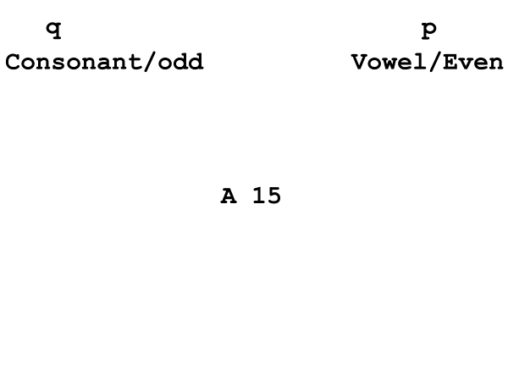 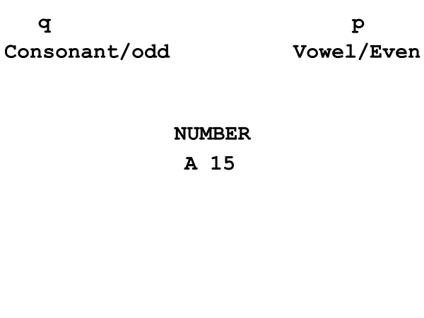

 

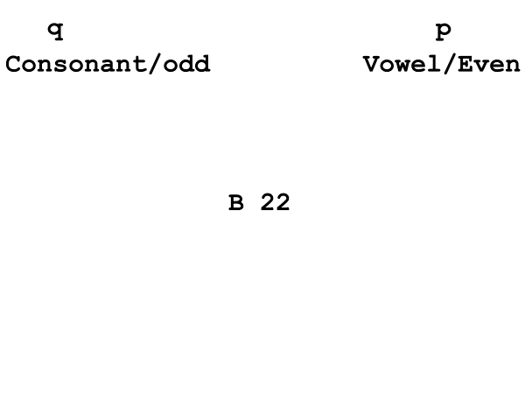 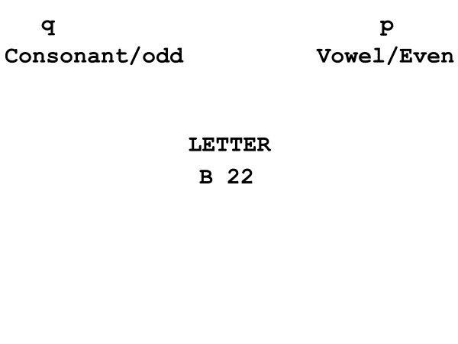

*Figure 1*. Time course for pure block trials (left) and switch block trials (right). Each trial was separated by a 500 ms intertrial delay in which participants viewed a blank screen (middle panels).

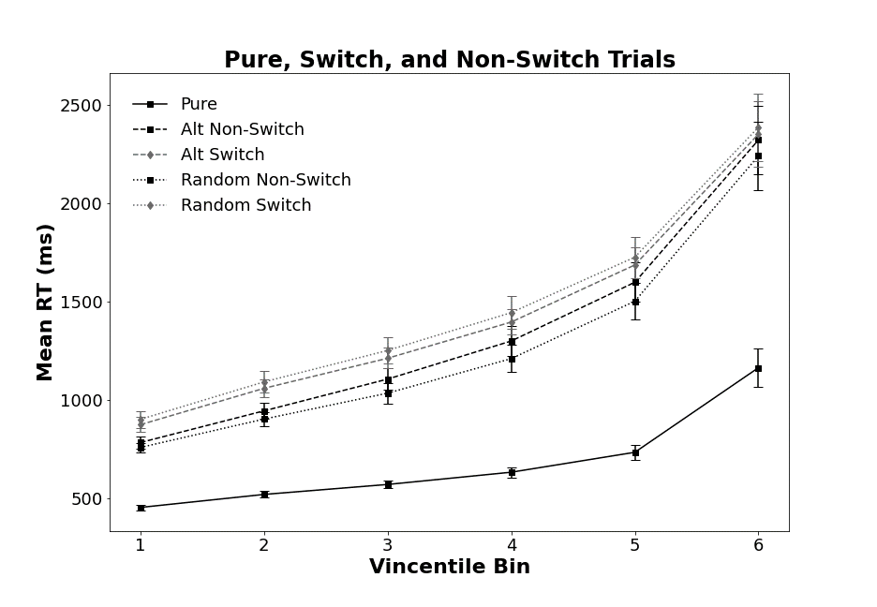

*Figure 2*. Mean RT Vincentile bin data points for pure, non-switch, and switch trials. Switch and non-switch trials are split by alternating runs and random presentation sequences. Bars denote 95% *CI*.

*Figure 3*. Local and global Vincentile costs for alternating runs and random switching. Bars denote 95% *CI*.